BIG MART ANALYSIS

1. Total number of unique items in all outlet.
Item identifier has 1559 unique items.

2. Item_Fat_Content

Products are divided into two types low fat and regular. Following is the total count of product sold as per fat content.

Low Fat 5517
Regular 3006
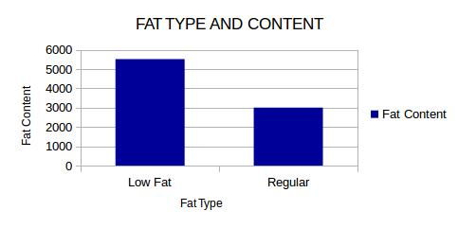
Record shows big mart outlet stocks more low fat product.

3.Fat content and product sales

SELECT item_fat_content, count(*) as product_count, cast(sum(item_outlet_sales) as decimal(20,2))as sales
FROM big_mart_final
GROUP BY item_fat_content;

Low Fat 5517 11904094.53
Regular 3006 6687030.88
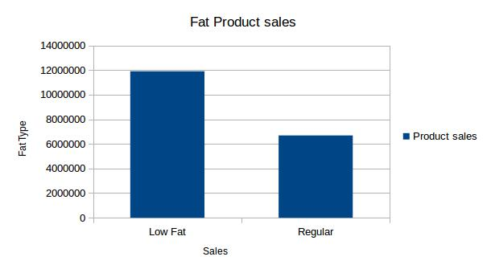
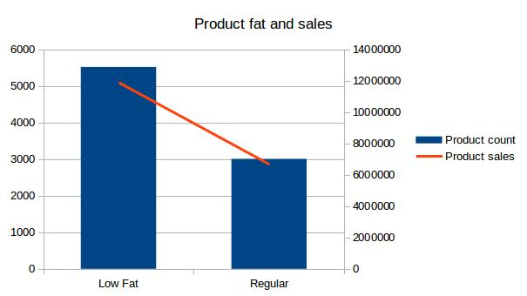
Record show product with low fat contents are in more demand as people are becoming more health conscious. Thus, outlet stocks more products having low fat content.

3. Unique outlets

There are total 10 outlet of Big Mart:-
OUT010
OUT013
OUT017
OUT018
OUT019
OUT027
OUT035
OUT045
OUT046
OUT049

4. Unique outlet size

following are the sizes of outlet:-

High
Medium
Small

5. oultet and its size

High OUT013
Medium OUT018
Medium OUT027
Medium OUT049
Small OUT010
Small OUT017
Small OUT019
Small OUT035
Small OUT045
Small OUT046

Following record shows that there are more number of small outlet, while only one outlet is of size High.
6. outlet location type

check type of city in which the store is located
cities are divided in three category:-
Tier 1
Tier 2
Tier 3

7.find type of outlet

SELECT DISTINCT(outlet_type)
FROM big_mart_final;

outlet are categorized into 4 types:-
Grocery Store
Supermarket Type1
Supermarket Type2
Supermarket Type3

7.outlet located in different tier

Location type Outlet
Tier 1 OUT019
Tier 1 OUT046
Tier 1 OUT049
Tier 2 OUT017
Tier 2 OUT035
Tier 2 OUT045
Tier 3 OUT010
Tier 3 OUT013
Tier 3 OUT018
Tier 3 OUT027

record shows that big mart has evenly divided outlet in all type of location type.

8. Total number of product across at various outlet

following is the record for total number of product at each oultet.
Outlet Total Products
OUT010 555
OUT013 932
OUT017 926
OUT018 928
OUT019 528
OUT027 935
OUT035 930
OUT045 929
OUT046 930
OUT049 930

9.find type of outlet

SELECT DISTINCT(outlet_type)
FROM big_mart_final;

outlet are categorized into 4 types:-
Grocery Store
Supermarket Type1
Supermarket Type2
Supermarket Type3

10.find which outlet is of what type

SELECT outlet_type, outlet_identifier
FROM big_mart_final
GROUP BY outlet_type, outlet_identifier
Outlet Type Oultet
Grocery Store OUT010
Grocery Store OUT019
Supermarket Type1 OUT013
Supermarket Type1 OUT017
Supermarket Type1 OUT035
Supermarket Type1 OUT045
Supermarket Type1 OUT046
Supermarket Type1 OUT049
Supermarket Type2 OUT018
Supermarket Type3 OUT027

There are two grocery stores while most outlet is of type Supermarket Type1. This shows people prefers buying items at one place.

11. Lets check in which location type this outlet are present

SELECT outlet_location_type, outlet_type, outlet_identifier
FROM big_mart_final
GROUP BY outlet_location_type,outlet_type, outlet_identifier
Location type Outlet type Outlet
Tier 1 Grocery Store OUT019
Tier 1 Supermarket Type1 OUT046
Tier 1 Supermarket Type1 OUT049
Tier 2 Supermarket Type1 OUT017
Tier 2 Supermarket Type1 OUT035
Tier 2 Supermarket Type1 OUT045
Tier 3 Grocery Store OUT010
Tier 3 Supermarket Type1 OUT013
Tier 3 Supermarket Type2 OUT018
Tier 3 Supermarket Type3 OUT027

Record shows people in Tier 1 and 2 prefers buying product at one place i.e SuperMarket Type 1. While Tier 3 has all type of SuperMarket. Looking at the demand in tier 3 big mart has eastablished four oultet of one High size ,two Medium size and one small size. While tier 1 and tier 2 has 3 outlet each of small and medium size.
12. Outlet with total sales

SELECT outlet_identifier, ROUND(sum(item_outlet_sales),2) as total_sales
FROM big_mart_final
GROUP BY outlet_identifier
ORDER BY total_sales;

sales at each outlet:-
Outlet Total Sales
OUT019 179694.09
OUT010 188340.17
OUT018 1851822.83
OUT045 2036725.48
OUT046 2118395.17
OUT013 2142663.58
OUT017 2167465.29
OUT049 2183969.81
OUT035 2268122.94
OUT027 3453926.05
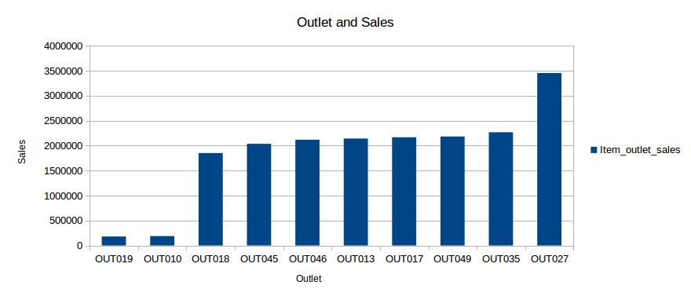
record shows outlet OUT027 has most sales.

13. outlet sales in different location type and size

SELECT outlet_location_type, outlet_type, outlet_size,outlet_identifier,cast(sum(item_outlet_sales) as decimal(20,2))as sales
FROM big_mart_final
GROUP BY outlet_location_type,outlet_type, outlet_size,outlet_identifier

Location type Outlet type Outlet size Outlet ID Total sales
Tier 1 Grocery Store Small OUT019 179694.09
Tier 1 Supermarket Type1 Medium OUT049 2183969.81
Tier 1 Supermarket Type1 Small OUT046 2118395.17
Tier 2 Supermarket Type1 Small OUT017 2167465.29
Tier 2 Supermarket Type1 Small OUT035 2268122.94
Tier 2 Supermarket Type1 Small OUT045 2036725.48
Tier 3 Grocery Store Small OUT010 188340.17
Tier 3 Supermarket Type1 High OUT013 2142663.58
Tier 3 Supermarket Type2 Medium OUT018 1851822.83
Tier 3 Supermarket Type3 Medium OUT027 3453926.05
Following records show that sales record are not dependent on size of outlet. Figure of sales in small and high outlet are close enough with little difference, except for outlet that are grocery store. Grocery stores contains less amount of product compare to all-in-one stores. Its obvious for grocery stores to have lower sales.

In tier 3 oultet of size high has same number of sales compare to small and medium size oultet. It shows buyers in tier 3 prefers small outlet compare to buyers in tier 1 who prefers going to medium size outlet. while tier 2 has only small outlet with almost equal number of sales.

We saw size of outlet doesn't affects the sales figure. But we also need to take into consideration the outlet year of service. Older outlets will have more sales compare to new outlet irrespective of size of outlet. Hence we will analysis the record using age parameter of outlet.

20. Find the outlets year of establishment and number of years working.

SELECT outlet_identifier, outlet_year, (2013 - outlet_year) as est_year
FROM big_mart_final
GROUP BY outlet_identifier, outlet_year
ORDER BY est_year;

Outlet Establishment Year Years
OUT018 2009 4.0
OUT017 2007 6.0
OUT035 2004 9.0
OUT045 2002 11.0
OUT049 1999 14.0
OUT010 1998 15.0
OUT046 1997 16.0
OUT013 1987 26.0
OUT019 1985 28.0
OUT027 1985 28.0

14. Find how much old each outlets are. Here we are subtracting year of establishment with 2013 as this records was collected in 2013.

SELECT outlet_identifier,(2013-outlet_year) as year,ROUND(sum(item_outlet_sales),2) as outlet_sales
FROM big_mart_final
GROUP BY outlet_identifier,outlet_year
ORDER BY year;

Outlet Years Total Sales
OUT018 4.0 1851822.83
OUT017 6.0 2167465.29
OUT035 9.0 2268122.94
OUT045 11.0 2036725.48
OUT049 14.0 2183969.81
OUT010 15.0 188340.17
OUT046 16.0 2118395.17
OUT013 26.0 2142663.58
OUT027 28.0 3453926.05
OUT019 28.0 179694.09

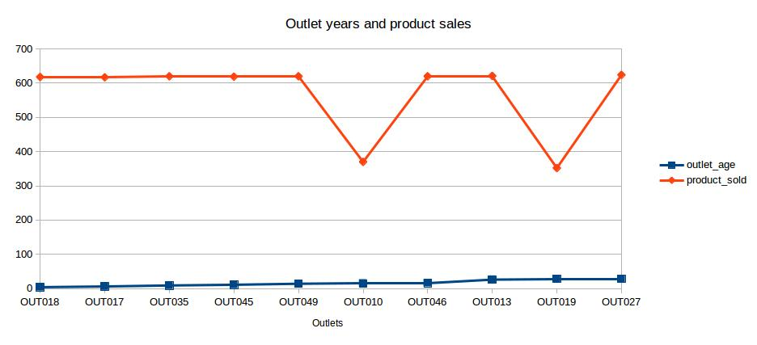
15. Now we will analyze the product sales FROM each outlet with its year of service

SELECT outlet_location_type, outlet_type, outlet_size,outlet_identifier,(2013 - outlet_year) as year,cast(sum(item_outlet_sales) as decimal(20,2))as sales
FROM big_mart_final
GROUP BY outlet_location_type,outlet_type, outlet_size,outlet_identifier,outlet_year;

Location type Outlet type Outlet size Outlet ID Years Total sales
Tier 1 Grocery Store Small OUT019 28.0 179694.09
Tier 1 Supermarket Type1 Medium OUT049 14.0 2183969.81
Tier 1 Supermarket Type1 Small OUT046 16.0 2118395.17
Tier 2 Supermarket Type1 Small OUT017 6.0 2167465.29
Tier 2 Supermarket Type1 Small OUT035 9.0 2268122.94
Tier 2 Supermarket Type1 Small OUT045 11.0 2036725.48
Tier 3 Grocery Store Small OUT010 15.0 188340.17
Tier 3 Supermarket Type1 High OUT013 26.0 2142663.58
Tier 3 Supermarket Type2 Medium OUT018 4.0 1851822.83
Tier 3 Supermarket Type3 Medium OUT027 28.0 3453926.05

Previously we saw outlet OUT027 of medium size has highest sales. Here, we can see outlet year of service has direct impact on sales record. OUT027 is 28 years old making it one of the oldest outlet. Thus its has most sales.

Both Grocery stores are of small size, but grocery store sales in tier 3 is more compare to older grocery store FROM tier 1. This shows that their is more demand in tier 3.

Considering all location type, its been observed that sales of new and old outlet is same. in some cases new oultet that are just 4 to 5 yrsold has overtaken old outlet that are been in market for more than 25 years.

Tier 2 outlet are new compare to outlet in Tier 1 but has almost equal amount of sales. This show tier 2 also has more demand.
This can be futher clarrified by total sales in each Tier.

16. Sales in each tier

SELECT outlet_location_type,ROUND(sum(item_outlet_sales),2) FROM big_mart_final
GROUP BY outlet_location_type;
Tier 1 4482059.07
Tier 2 6472313.71
Tier 3 7636752.63
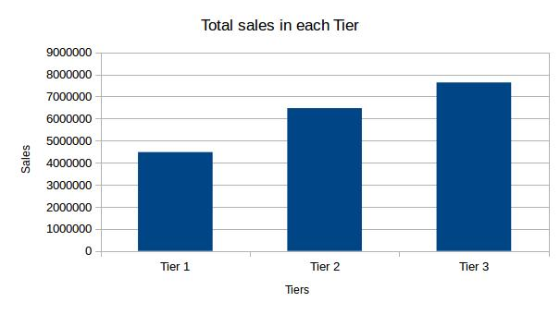
We saw year of service of each outlet directly impacts the number of sales. Now we will also consider visibility parameter of item. And analysis how it impacts total sales.

17.visibility and product sales
we will consider item_type to analyze the impact of visibility on sales.

SELECT item_type, ROUND(SUM(item_visibility)*100,2) as visibility,cast(sum(item_outlet_sales) as decimal(20,2))as sales
FROM big_mart_final
GROUP BY item_type
ORDER BY sales desc ;

Item type Visibility Item Sales
Fruits and Vegetables 8440.79 2820059.82
Snack Foods 8022.03 2732786.09
Household 5580.33 2055493.71
Frozen Foods 5619.23 1825734.79
Dairy 4939.53 1522594.05
Canned 4421.59 1444151.49
Baking Goods 4482.17 1265525.34
Health and Hygiene 2871.23 1045200.14
Meat 2647.06 917565.61
Soft Drinks 2846.77 892897.72
Breads 1663.0 553237.19
Hard Drinks 1389.77 457793.43
Starchy Foods 999.94 351401.25
Others 1018.07 325517.61
Breakfast 942.95 232298.95
Seafood 479.85 148868.22

Record show item with high visibility has higher sales.

18. We will analyze visibilty and sales percentage.

SELECT item_type, ROUND(SUM(item_visibility)*100/c.value,2) as visibility,cast(sum(item_outlet_sales)*100/b.val as decimal(20,2))as sales
FROM big_mart_final a,(SELECT sum(item_outlet_sales) as val FROM big_mart_final) b, (SELECT sum(item_visibility) as value FROM big_mart_final) c
GROUP BY item_type,c.value,b.val
ORDER BY sales desc;

Item_Type Visibility_percentage Sales_percentage
Fruits and Vegetables 14.98 15.17
Snack Foods 14.23 14.7
Household 9.9 11.06
Frozen Foods 9.97 9.82
Dairy 8.76 8.19
Canned 7.84 7.77
Baking Goods 7.95 6.81
Health and Hygiene 5.09 5.62
Meat 4.7 4.94
Soft Drinks 5.05 4.8
Breads 2.95 2.98
Hard Drinks 2.47 2.46
Starchy Foods 1.77 1.89
Others 1.81 1.75
Breakfast 1.67 1.25
Seafood 0.85 0.8
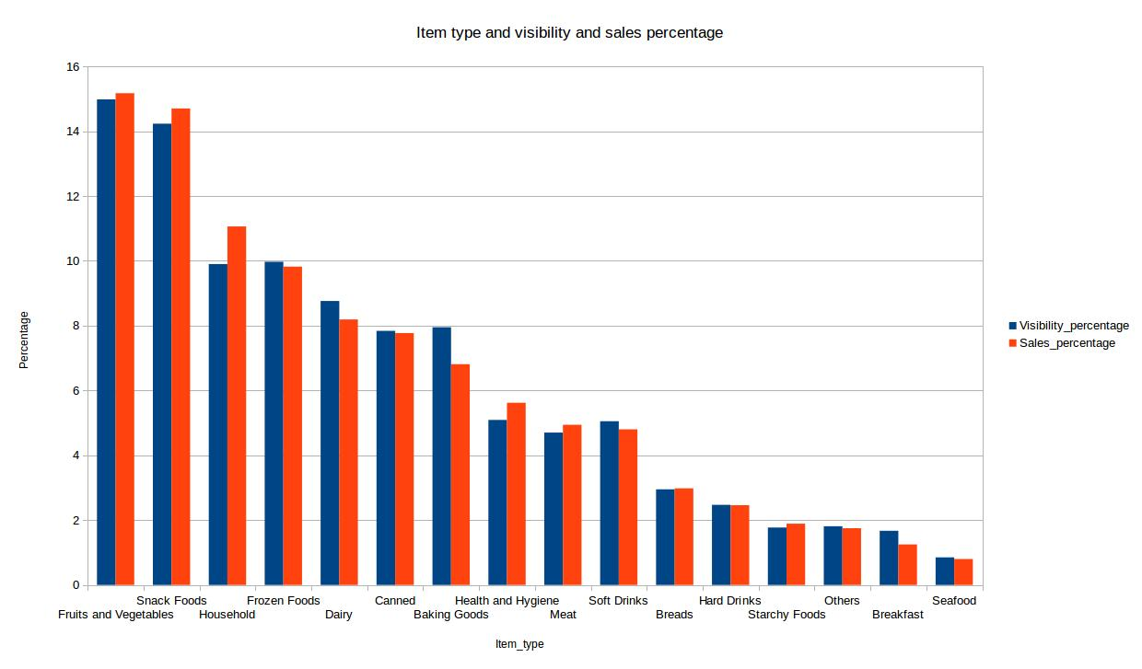
Data show item with high visibility are sold more compare to product with lower visibility.

19. We will analyze sales of product depending on fat content.

SELECT a.item_type,c.cv , d.fg,c.cv-d.fg
FROM big_mart_final a left join (SELECT item_type,count(item_fat_content) as cv
FROM big_mart_final
where item_fat_content="Low Fat"
GROUP BY item_type
) c on a.item_type=c.item_type left join (SELECT item_type,count(item_fat_content) as fg
FROM big_mart_final
where item_fat_content="Regular"
GROUP BY item_type) d on
a.item_type=d.item_type
GROUP BY a.item_type,c.cv , d.fg;

ITEM_TYPE LOW FAT REGULAR DIFFERENCE
Baking Goods 580523.67 685001.67 -104478
Breads 305680.76 247556.42 58124.34
Breakfast 99441.89 132857.06 -33415.17
Canned 753171.6 690979.89 62191.71
Dairy 896682.79 625911.26 270771.53
Frozen Foods 952890.96 872843.83 80047.13
Fruits and Vegetables 1374915.62 1445144.2 -70228.58
Hard Drinks 457793.43 NULL NULL
Health and Hygiene 1045200.14 NULL NULL
Household 2055493.71 NULL NULL
Meat 346054.88 571510.74 -225455.86
Others 325517.61 NULL NULL
Seafood 70588.12 78280.1 -7691.98
Snack Foods 1669089.36 1063696.73 605392.63
Soft Drinks 761259.08 131638.65 629620.43
Starchy Foods 209790.92 141610.33 68180.59
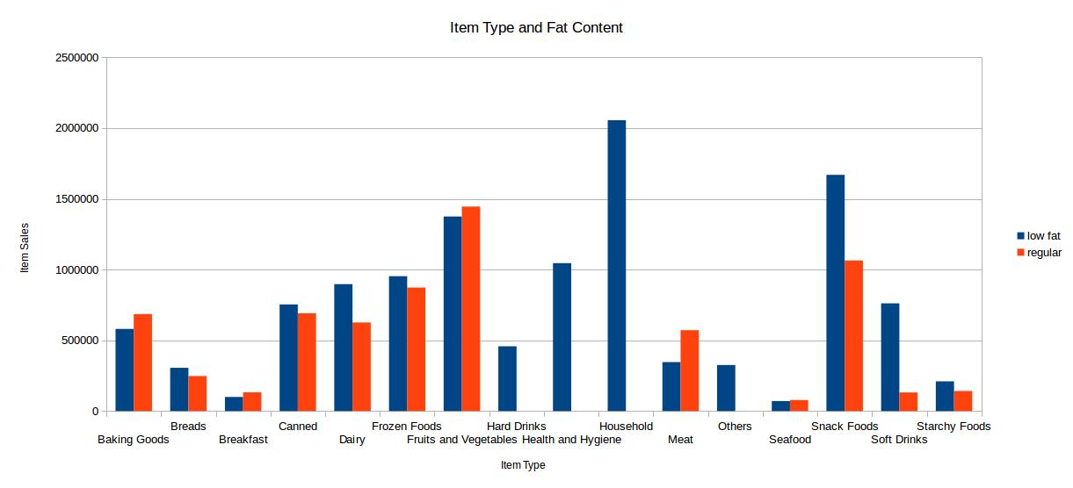
Record show people prefers buying low fat content when it comes to buying household and daily intake items.

20. Which are top 10 product with heavy weight

SELECT item_identifier,item_type,item_weight
FROM big_mart_final
GROUP BY item_identifier,item_type,item_weight
ORDER BY item_weight desc
limit 10;

FDR07 Fruits and Vegetables 21.35
FDC02 Canned 21.35
NCX17 Health and Hygiene 21.25
FDA45 Snack Foods 21.25
NCO42 Household 21.25
FDQ21 Snack Foods 21.25
FDT03 Meat 21.25
FDW10 Snack Foods 21.2
FDG35 Starchy Foods 21.2
NCE42 Household 21.1

21. Which outlet has highest sales

SELECT v.outlet_identifier, v.finalval FROM (SELECT x.outlet_identifier,cast(sum(item_outlet_sales) as decimal(20,2)) as finalval FROM big_mart_final x GROUP BY x.outlet_identifier) v join (SELECT max(b.counter) as total FROM (SELECT outlet_identifier,cast(sum(item_outlet_sales) as decimal(20,2)) as counter FROM big_mart_final GROUP BY outlet_identifier) b) g where v.finalval=g.total;

OUT027 3453926.05

22. in which outlet type of item are sold more

INSERT OVERWRITE LOCAL DIRECTORY '/home/hduser/big_mart_output/test7/'
ROW FORMAT DELIMITED FIELDS TERMINATED BY ','
SELECT item_type,outlet_identifier, cast(sum(item_outlet_sales) as decimal(20,2))as sales
FROM big_mart_final
GROUP BY item_type,outlet_identifier;
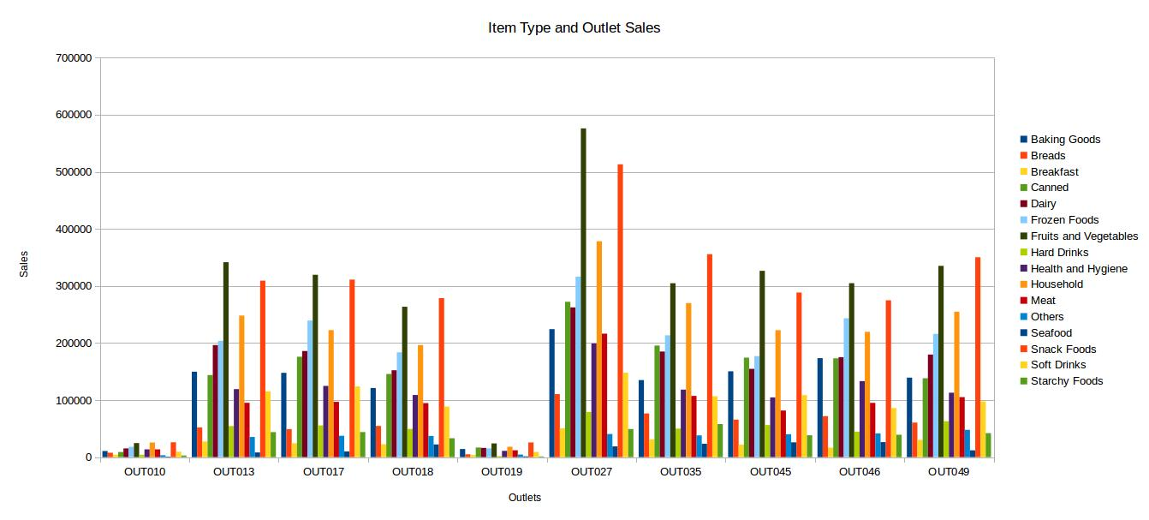
23. Find Amount of product sold in each item type

SELECT a.item_type,MAX(a.total_val)
FROM(
SELECT item_type, outlet_identifier,count(*) as total_val
FROM big_mart_final
GROUP BY item_type,outlet_identifier
) a
GROUP BY a.item_type;

Baking Goods 53
Breads 22
Breakfast 10
Canned 53
Dairy 58
Frozen Foods 73
Fruits and Vegetables 94
Hard Drinks 19
Health and Hygiene 43
Household 74
Meat 41
Others 15
Seafood 5
Snack Foods 96
Soft Drinks 35
Starchy Foods 16

Snack Food and Fruit and vegetable are sold more, while demand for sea food and breakfast is very low. Data also show people prefers buying frozen food.

